Lab Report

Subject: Cryptography

Title: Implementation of Classical Cipher Techniques in C

1. Objective
The objective of this laboratory work is to demonstrate the working of various classical cipher techniques by implementing them using the C programming language. This lab helps in understanding basic encryption and decryption processes used in classical cryptography.

2. Theory
Cryptography is the science of securing information by transforming it into an unreadable format so that only authorized parties can access it. Classical cryptography mainly relies on substitution and transposition techniques. Although these methods are not secure by modern standards, they form the foundation of modern cryptographic algorithms.

3. Caesar Cipher

3.1 Description
The Caesar Cipher is one of the simplest and oldest substitution cipher techniques. In this method, each letter in the plaintext is shifted by a fixed number of positions down the alphabet. The number of positions shifted is known as the key.
For example, with a shift of 3: - A → D - B → E - Z → C

3.2 Algorithm
Encryption: 1. Take the plaintext message 2. Choose a shift value (key) 3. Shift each alphabetic character by the key value 4. Generate the ciphertext
Decryption: 1. Take the ciphertext 2. Shift each character backward by the same key 3. Obtain the original plaintext

3.3 Source Code (C)

#include <stdio.h>
#include <string.h>
#include <ctype.h>

int main()
{
char plain_text[20], cipher_text[20];
int key, i, length;

printf("Enter the plain text: ");
scanf("%s", plain_text);

printf("Enter the key value: ");
scanf("%d", &key);

key = key % 26; // To handle large key values
length = strlen(plain_text);

printf("\nThe plain text is: %s", plain_text);
printf("\nThe encrypted text is: ");

/* Encryption */
for (i = 0; i < length; i++)
{
if (isupper(plain_text[i]))
{
cipher_text[i] = ((plain_text[i] - 'A' + key) % 26) + 'A';
}
else if (islower(plain_text[i]))
{
cipher_text[i] = ((plain_text[i] - 'a' + key) % 26) + 'a';
}
else
{
cipher_text[i] = plain_text[i];
}

printf("%c", cipher_text[i]);
}

printf("\nThe decrypted text is: ");

/* Decryption */
for (i = 0; i < length; i++)
{
if (isupper(cipher_text[i]))
{
plain_text[i] = ((cipher_text[i] - 'A' - key + 26) % 26) + 'A';
}
else if (islower(cipher_text[i]))
{
plain_text[i] = ((cipher_text[i] - 'a' - key + 26) % 26) + 'a';
}
else
{
plain_text[i] = cipher_text[i];
}

printf("%c", plain_text[i]);
}

return 0;
}

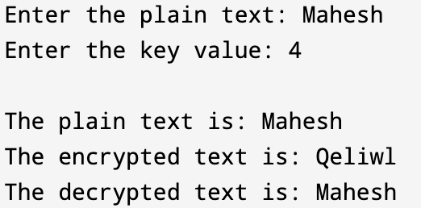

3.4 Result
The plaintext is successfully converted into ciphertext using the shift key, and the original message is recovered after decryption.

4. Monoalphabetic Cipher

4.1 Description
A Monoalphabetic Cipher is a substitution cipher where each letter of the plaintext is replaced with a corresponding letter from a fixed substitution alphabet. Unlike the Caesar Cipher, the substitution is not limited to shifting and can be any random mapping of alphabets.

4.2 Algorithm
Encryption: 1. Define a substitution key (mapping of alphabets) 2. Replace each plaintext character with its mapped character 3. Generate the ciphertext
Decryption: 1. Use the reverse mapping of the substitution key 2. Replace each ciphertext character accordingly 3. Retrieve the original plaintext

4.3 Source Code (C)

#include <stdio.h>
#include <ctype.h>

char mono_encrypt(char);

/* Monoalphabetic substitution table */
char alpha[26][2] = {
{'a','f'}, {'b','a'}, {'c','g'}, {'d','u'}, {'e','n'},
{'f','i'}, {'g','j'}, {'h','k'}, {'i','l'}, {'j','m'},
{'k','o'}, {'l','p'}, {'m','q'}, {'n','r'}, {'o','s'},
{'p','t'}, {'q','v'}, {'r','w'}, {'s','x'}, {'t','y'},
{'u','z'}, {'v','b'}, {'w','c'}, {'x','d'}, {'y','e'},
{'z','h'}
};

int main()
{
char str[50], cipher[50];
int i;

printf("Enter the string: ");
fgets(str, sizeof(str), stdin);

/* Encryption */
for (i = 0; str[i] != '\0'; i++)
{
cipher[i] = mono_encrypt(str[i]);
}
cipher[i] = '\0';

printf("\nPlain Text : %s", str);
printf("Cipher Text : %s", cipher);

return 0;
}

/* Function to encrypt a character */
char mono_encrypt(char ch)
{
int i;

if (isalpha(ch))
{
ch = tolower(ch);

for (i = 0; i < 26; i++)
{
if (ch == alpha[i][0])
return alpha[i][1];
}
}

/* Return character unchanged if not alphabet */
return ch;
}

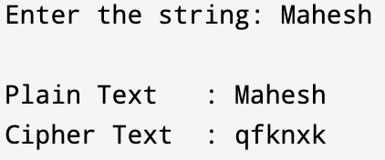

4.4 Result
The plaintext is encrypted using a fixed substitution alphabet and successfully decrypted using the reverse mapping.

5. Hill Cipher

5.1 Description
The Hill Cipher is a polygraphic substitution cipher based on linear algebra. It uses matrix multiplication modulo 26 to encrypt blocks of plaintext letters. The key is a square matrix, and its inverse is used for decryption.

5.2 Algorithm
Encryption: 1. Convert plaintext characters into numerical values (A=0 to Z=25) 2. Arrange plaintext into vectors of size n 3. Multiply the vector with the key matrix modulo 26 4. Convert the result back to characters
Decryption: 1. Find the inverse of the key matrix modulo 26 2. Multiply ciphertext vectors with the inverse matrix 3. Convert numbers back to characters

5.3 Source Code (C)

#include <stdio.h>
#include <string.h>
#include <ctype.h>

int mod26(int x);

/* 2x2 Key Matrix (must have determinant coprime with 26) */
int key[2][2] = {
{3, 3},
{2, 5}
};

int main()
{
char plain[50], cipher[50];
int i, p1, p2, c1, c2;

printf("Enter the plain text: ");
scanf("%s", plain);

int len = strlen(plain);

/* If length is odd, append 'x' */
if (len % 2 != 0)
{
plain[len] = 'x';
plain[len + 1] = '\0';
len++;
}

/* Encryption */
for (i = 0; i < len; i += 2)
{
p1 = tolower(plain[i]) - 'a';
p2 = tolower(plain[i + 1]) - 'a';

c1 = mod26(key[0][0] * p1 + key[0][1] * p2);
c2 = mod26(key[1][0] * p1 + key[1][1] * p2);

cipher[i] = c1 + 'a';
cipher[i + 1] = c2 + 'a';
}

cipher[len] = '\0';

printf("\nPlain Text : %s", plain);
printf("\nCipher Text : %s\n", cipher);

return 0;
}

/* Function to handle modulo 26 */
int mod26(int x)
{
return (x % 26 + 26) % 26;
}

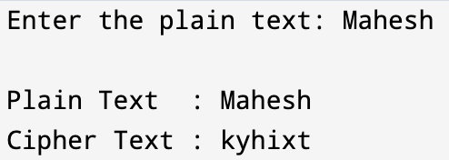

5.4 Result
The plaintext is encrypted using matrix operations and correctly decrypted using the inverse matrix.

6. Vigenère Cipher

6.1 Description
The Vigenère Cipher is a polyalphabetic substitution cipher that uses a keyword to encrypt the plaintext. Each letter of the plaintext is shifted according to the corresponding letter of the keyword.

6.2 Algorithm
Encryption: 1. Choose a keyword 2. Repeat the keyword to match the plaintext length 3. Shift each plaintext character based on the keyword character 4. Produce the ciphertext
Decryption: 1. Use the same keyword 2. Shift characters backward based on keyword values 3. Obtain the original plaintext

6.3 Source Code (C)

#include <stdio.h>
#include <string.h>
#include <ctype.h>

/* Function prototypes */
void encryptVigenere(char *, char *, char *);
void decryptVigenere(char *, char *, char *);

int main()
{
char plaintext[100], key[100], ciphertext[100], decrypted[100];

printf("Enter the plaintext: ");
fgets(plaintext, sizeof(plaintext), stdin);

/* Remove newline if fgets reads it */
plaintext[strcspn(plaintext, "\n")] = '\0';

printf("Enter the key: ");
fgets(key, sizeof(key), stdin);
key[strcspn(key, "\n")] = '\0';

encryptVigenere(plaintext, key, ciphertext);
printf("\nEncrypted Text: %s\n", ciphertext);

decryptVigenere(ciphertext, key, decrypted);
printf("Decrypted Text: %s\n", decrypted);

return 0;
}

/* Encryption function */
void encryptVigenere(char *text, char *key, char *cipher)
{
int i, j = 0;
int keyLen = strlen(key);

for (i = 0; text[i] != '\0'; i++)
{
char ch = text[i];

if (isalpha(ch))
{
int k = tolower(key[j % keyLen]) - 'a'; // key index
if (isupper(ch))
cipher[i] = ((ch - 'A' + k) % 26) + 'A';
else
cipher[i] = ((ch - 'a' + k) % 26) + 'a';

j++; // increment key index only for letters
}
else
{
cipher[i] = ch; // non-letter characters remain unchanged
}
}
cipher[i] = '\0';
}

/* Decryption function */
void decryptVigenere(char *cipher, char *key, char *text)
{
int i, j = 0;
int keyLen = strlen(key);

for (i = 0; cipher[i] != '\0'; i++)
{
char ch = cipher[i];

if (isalpha(ch))
{
int k = tolower(key[j % keyLen]) - 'a'; // key index
if (isupper(ch))
text[i] = ((ch - 'A' - k + 26) % 26) + 'A';
else
text[i] = ((ch - 'a' - k + 26) % 26) + 'a';

j++; // increment key index only for letters
}
else
{
text[i] = ch; // non-letter characters remain unchanged
}
}
text[i] = '\0';
}

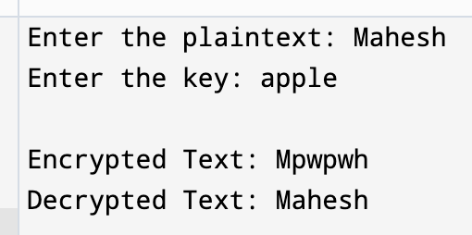

6.4 Result
The plaintext is securely encrypted using a keyword and successfully decrypted using the same key.

7. Rail Fence Cipher

7.1 Description
The Rail Fence Cipher is a transposition cipher that writes the plaintext in a zig-zag pattern across multiple rails and then reads it row by row to form the ciphertext.

7.2 Algorithm
Encryption: 1. Choose the number of rails 2. Write the plaintext in a zig-zag manner across rails 3. Read the characters row-wise to form ciphertext
Decryption: 1. Reconstruct the zig-zag pattern 2. Fill characters row-wise 3. Read the message in zig-zag order

7.3 Source Code (C)

#include <stdio.h>
#include <string.h>

/* Function prototypes */
void encryptRailFence(char *, int, char *);
void decryptRailFence(char *, int, char *);

int main() {
char plaintext[100], ciphertext[100], decrypted[100];
int key;

printf("Enter the plaintext: ");
fgets(plaintext, sizeof(plaintext), stdin);
plaintext[strcspn(plaintext, "\n")] = '\0'; // remove newline

printf("Enter the key (number of rails): ");
scanf("%d", &key);

encryptRailFence(plaintext, key, ciphertext);
printf("\nEncrypted Text: %s\n", ciphertext);

decryptRailFence(ciphertext, key, decrypted);
printf("Decrypted Text: %s\n", decrypted);

return 0;
}

/* Encryption function */
void encryptRailFence(char *text, int key, char *cipher) {
int len = strlen(text);
int i, row, col = 0;
int dir_down;

/* Create the rail matrix */
char rail[key][len];
for (i = 0; i < key; i++)
for (int j = 0; j < len; j++)
rail[i][j] = '\n';

row = 0;
dir_down = 0; // initially moving up

for (i = 0; i < len; i++) {
rail[row][col++] = text[i];

if (row == 0 || row == key - 1)
dir_down = !dir_down;

row += dir_down ? 1 : -1;
}

/* Read the matrix row-wise to get cipher text */
int idx = 0;
for (i = 0; i < key; i++)
for (int j = 0; j < len; j++)
if (rail[i][j] != '\n')
cipher[idx++] = rail[i][j];

cipher[idx] = '\0';
}

/* Decryption function */
void decryptRailFence(char *cipher, int key, char *text) {
int len = strlen(cipher);
int i, row, col;
int dir_down;

/* Create the rail matrix */
char rail[key][len];
for (i = 0; i < key; i++)
for (int j = 0; j < len; j++)
rail[i][j] = '\n';

/* Mark the positions with '*' */
row = 0;
dir_down = 0;
for (i = 0; i < len; i++) {
rail[row][i] = '*';

if (row == 0 || row == key - 1)
dir_down = !dir_down;

row += dir_down ? 1 : -1;
}

/* Fill the cipher text in marked positions */
int idx = 0;
for (i = 0; i < key; i++)
for (int j = 0; j < len; j++)
if (rail[i][j] == '*' && idx < len)
rail[i][j] = cipher[idx++];

/* Read the matrix in zig-zag to get plaintext */
row = 0;
dir_down = 0;
idx = 0;
for (col = 0; col < len; col++) {
text[idx++] = rail[row][col];

if (row == 0 || row == key - 1)
dir_down = !dir_down;

row += dir_down ? 1 : -1;
}

text[idx] = '\0';
}

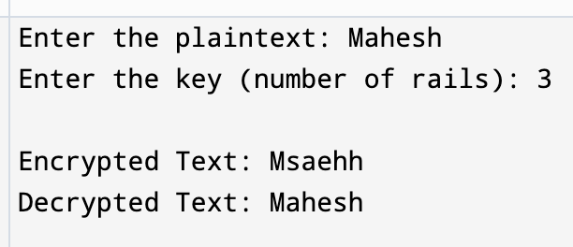

7.4 Result
The plaintext is rearranged using a rail-based pattern and correctly restored after decryption.

8. Conclusion
In this laboratory work, various classical cipher techniques were successfully studied and implemented using the C programming language. Each cipher demonstrated a different approach to encryption, ranging from simple substitution to matrix-based transformations and transposition techniques. Although these ciphers are not secure against modern attacks, they play a crucial role in understanding the fundamentals of cryptography and form the basis for advanced encryption algorithms.

9. References
- William Stallings, Cryptography and Network Security
- Cryptography lecture notes
- Standard textbooks on Information Security

